INTENSIVE SPANISH LANGUAGE & CULTURE PROGRAMME (2010 Edition)
for students from Tsinghua University and Beijing Institute of Technology (China)
organized by PROLINTER
UNIVERSIDAD POLITÉCNICA DE MADRID (UPM)

DESCRIPTION
This programme has been especially designed for students from Tsinghua University and Beijing Institute of Technology (China), as a project organized by the Languages Programme for International Students (PROLINTER) run by the Universidad Politécnica de Madrid (Vice-Rector’s Office for International Affairs).
This is an intensive four-week programme which includes linguistic and cultural components and highlights points of Spanish grammar, phonetics and vocabulary within a socio-cultural setting. The course, including several different Spanish scenarios, has been designed to give students a real taste of contemporary Spanish language and culture.

OBJECTIVES
The general objective is to build a Spanish language springboard as a basis for later learning, accomplishing the A1-A2 Language Level Communication Skills according to the Common European Framework of Reference for Languages (CEFRL):
U n d e r s t a n d i n g | Listening | I can understand familiar words and very basic phrases concerning myself, my family and immediate concrete surroundings when people speak slowly and clearly.
U n d e r s t a n d i n g | Reading | I can understand familiar names, words and very simple sentences, for example on notices and posters or in catalogues.
S p e a k i n g | Spoken interaction | I can interact in a simple way provided the other person is prepared to repeat or rephrase things at a slower rate of speech and help me formulate what I'm trying to say. I can ask and answer simple questions in areas of immediate need or on very familiar topics.
S p e a k i n g | Spoken production | I can use simple phrases and sentences to describe where I live and people I know.
 | Writing | I can write a short, simple postcard, for example sending holiday greetings. I can fill in forms with personal details, for example entering my name, nationality and address on a hotel registration form.

- Establish the necessary communication skills and strategies (comprehension and speaking) in Spanish for everyday situations in both academic (formal) and socio-cultural (informal) settings.
- Prompt and encourage interest and curiosity in Spanish culture, traditions and customs.

ACTIVITIES
- Communication skills (Grammar, vocabulary, etc) in-class face to face lessons.
- On line self learning activities (Tutors guidance).
- Exposure to situations with a combination of Spanish real world exposure with sound academic grounding. (UPM site)
- Formal and social presentations (In life recorded presentations)
- Portfolios design and implementation
- Team group projects
- Spanish negotiations
- Academic Blogs

METHODOLOGY
This course embraces the Blended Learning methodology extending the in-class programme through a series of on-line activities, supported, in this case, by the AVE (Virtual Spanish Classroom) programme offered by the Instituto Cervantes. These activities include the performance of self learning and self-assessment tasks and the participation in discussion fora.

ASSESSMENT
Students will be assessed according to the following strategies:
- Continuous assessment throughout the learning process.
- Final written examinations.
- Individual preparation and presentation of Portfolios.

MATERIALS
- Textbooks for in-class learning.
- Real-life and adapted material: magazines, newspapers, audio and video tapes, etc.
- In life presentations recording CDs
- AVE (Instituto Cervantes) Individual Licences

CULTURAL CONTENTS
- Participation in events related to:
- Spanish customs, compared with other foreign traditions (greetings, farewells, celebrations, etc.).
- Spanish stereotypes: tapas, siesta, local festivities, etc.
- Guided cultural walks around Madrid downtown: Cathedral, ancient heritage Churches, Museums, the Royal Palace, etc.
- Day trips to sightseeing attractions in the nearby areas of Madrid.
- Weekend trips to Barcelona / Sevilla (optional)
- Spanish cinema screening.

PARTICIPANTS
- 10 students per group.

COURSE DURATION
4 week course: 120 hours
- Spanish language and culture: 60 lecturing in-class hours.
- Team assignments: 10 hours
- Tutored and non-tutored individual and team assignments in the computer Lab (on-line materials): 30 hours.
- Extramural cultural activities: 20 hours

CERTIFICATE
Students will be issued with a Diploma / Certificate stating the course level (A1/2), and attained grade signed by PROLINTER UPM.

COURSE ENROLMENT FEES
- 10 students: Total Course Fee: 14.200,00 € (1.420,00 €/student)

The course enrolment fee covers:
  - Programme tuition (July 5 – 30)
  - Teaching materials (textbooks and photocopies)
  - Complementary teaching materials
  - Talks and films attendance.
  - Licence to use the AVE programme and on-line tutoring
  - Access to the E T S I MINAS ’s Computer Rooms for individual and team projects
  - Access to the university services (library, Internet, sports facilities, etc.)
  - Medical and accident insurance
  - Certificate of achievement with the obtained grade and accomplishment.
  - Accommodation: Single room (Breakfast) in University Residence Hall
  - Week days luncheons on UPM premises
  - Cultural programme:
    - 3 Guided tours to Madrid cultural areas
    - 3 guided visits to museums in Madrid
    - Guided tour of the Royal Palace
  - Guided visits to UPM Museums.
  - Meeting with representatives from the Chinese community in Spain
  - Tourist information package and UPM knapsack
  - Three ten ride (individual) vouchers (30 rides total) for metro and bus in Madrid
  - Madrid airport pick up and return shuttle service
  - Spanish SIM card for GSM cellular telephony
  - Welcome and farewell Parties organized by PROLINTER.
Expenses not included in the Enrolment fees:
  - Week days dinners. Approximate cost: 5-10 €/student (per day)
  - Weekends and Holidays luncheons and dinners. 10-20 €/student (per day)
  - Optional trips to Toledo and/or Segovia
  - Round trip Madrid-Barcelona or Madrid- Sevilla by high speed train/Bus
  - Other proposed trips on request

SUMMER PROGRAMME CALENDAR
2010
 | LEGEND  . - Arrival and departures.  . - Week working days. Academic activities  . - Sundays and local holidays  . – Cultural guided visits or 1-day trips  26 - Week-end excursions  - Beginning/end of the Academic programme
  JULY 10
  M | T | W | Th | F | S | Su
   |  |  | 1 | 2 | 3 | 4
  5 | 6 | 7 | 8 | 9 | 10 | 11
  12 | 13 | 14 | 15 | 16 | 17 | 18
  19 | 20 | 21 | 22 | 23 | 24 | 25
  26 | 27 | 28 | 29 | 30 | 31
  AUGUST 10
  M | T | W | Th | F | S | Su
   |  |  |  |  |  | 1

COURSE DETAILED SCHEDULE
- Fri. July 2
  - Participants’ arrival. (Check-in, etc.)
- Sat & Sun. July, 3, 4.
  - Participants’ arrival. (Check-in, etc.)
  - Optional excursions (Programme on request)

I.- Academic Programme
- Mon. July,5

  - 09:00h Official Opening of the programme.
  - 09:30h - 11:00h - Introduction to the Spanish language programme.
  - 11:00h - 11:30h - Coffee break.
  - 11:30h - 13:30h - Spanish language communication skills (Grammar, listening, speaking).
  - 13:30h - 15:30h - Lunch and free time for individual/team homework.
  - 15.30h - 17:30h - Introduction to the AVE tutoring computer system.
- Week days from Mon. to Thurs.

  - 09:00h - 11:00h - Spanish language communication skills (Grammar, listening, speaking).
  - 11:00h - 11:30h - Coffee break
  - 11:30h - 13:30h - Spanish language communication skills (Grammar, listening, speaking).
  - 13:30h - 15:30h - Lunch and free time for individual/team homework.
  - 15:30h - 17:30h - AVE tutoring computer system and computer assisted language tasks.
- Spanish language phonetics and intonation Seminar.
- Fridays
  - Cultural activities (included/optional in the Programme)

- Thur. July, 29
  - 09:00h - 13:30h - Final Evaluation Session: Final Project and Blogs presentation.

- Fri. July, 30
  - 13:00h - 14:30h - Closing Ceremony. Certificate awards. “Spanish Wine” Farewell reception.

End of the academic programme

II. - Cultural Programme
(Fry/Sat/Sun)

- Guided tour around Madrid downtown.(3 hours) (organized by BEST- MADRID International Students Group, UPM).
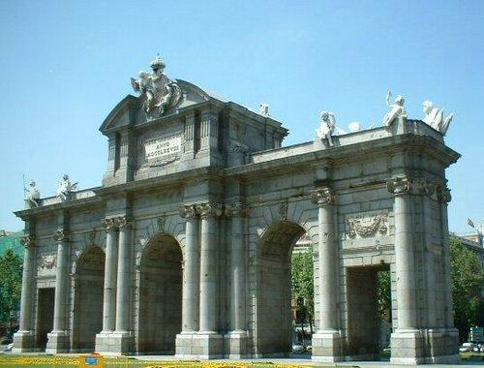

- Guided tour (3 hours) around “Bourbon’s Madrid”, including:
    - Visit to the Royal Palace
    - “Santa María la Real de la Almudena” Cathedral
    - Plaza de Oriente
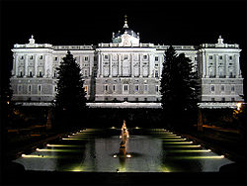

- Guided tour around “Hapsburg Madrid” (4 hours): The Golden Art Triangle I:
    - The Prado Museum: Goya and Velázquez
    - Guided walk around the area “el Madrid de las Letras”
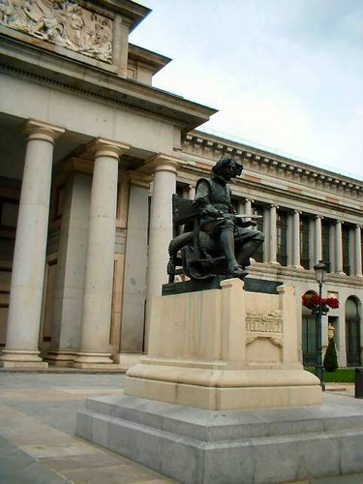

- Guided tour around “Hapsburg Madrid”: (4 hours) The Golden Art Triangle II
    - Museo Nacional “Centro de Arte Reina Sofía”: Picasso. 
    - Guided walk around the Golden Mile.
    - Museo Thyssen.
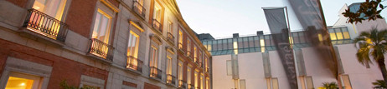

- UPM Museums Visits:

  - Museo de Ciencias. Escuela Técnica Superior de Ingenieros Industriales UPM.

  - Guided visit to La Mina and the Museo Historico- Minero. Escuela Técnica Superior de Ingenieros de Minas de Madrid UPM)

  - Guided trip to the Museo de la Informatica and “The Blue Brain Project”. Facultad de Informatica. UPM

- Guided trip to Toledo by shuttle with recorded information about the visiting monuments (9:00h - 17:00h)...

- Thur. July, 29- 22:00 h/...
  - 21:00 h/... Flamenco Show. (Out of the programme) (Specific arrangements (place and schedule) will be fixed along the week according to the students availability)

- July, 30

  - 13:00h - 14:30h - Closing Ceremony. Certificate awards. “Spanish Wine” Farewell reception.

End of the official programme

  - 14:30h - …h.

  - Pack up and check out at the Residence.

  - Departure for the optional (out of the programme) trips to Barcelona /Seville by high speed train/Bus. (http://www.renfe.es/ave/); http://www.alsa.es/portal/site/

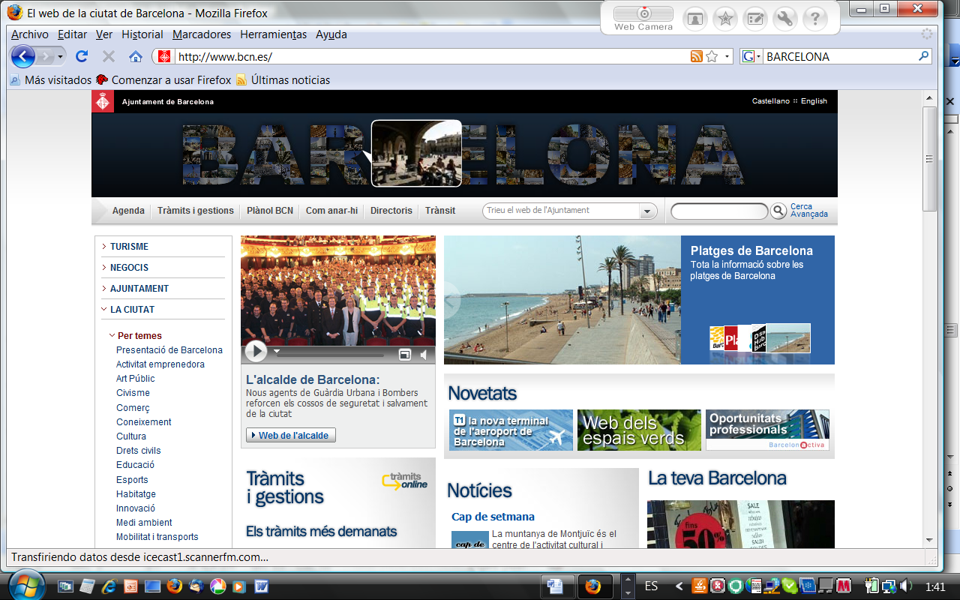
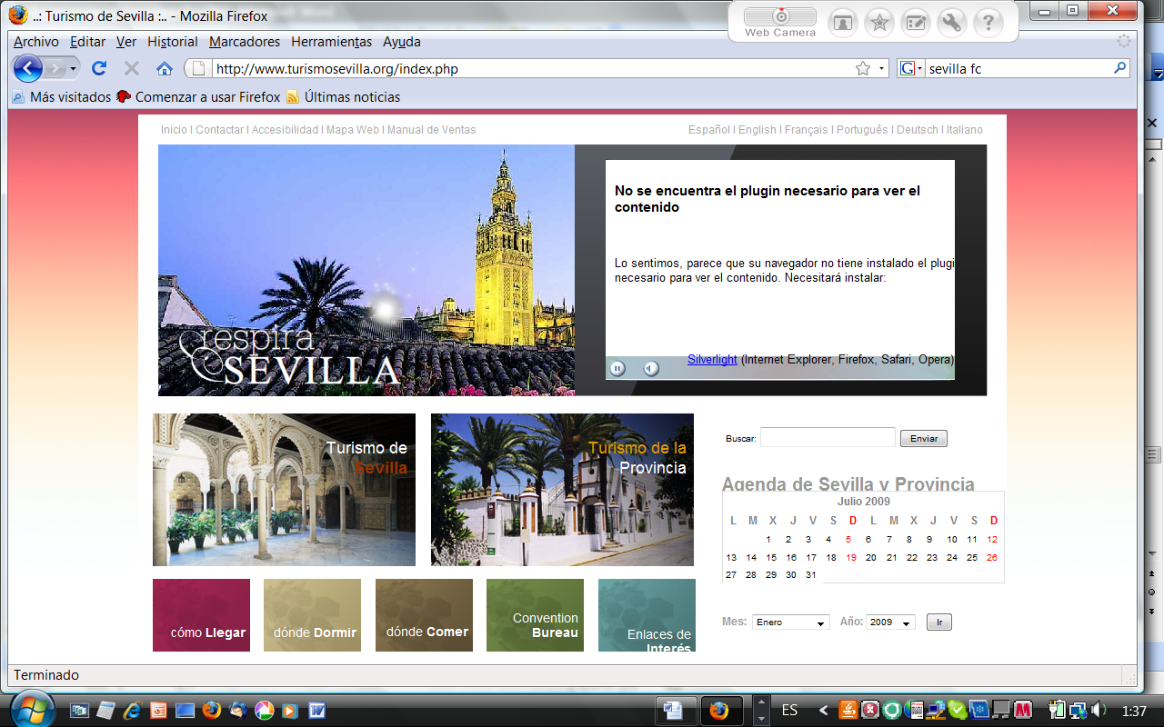

END OF PART 1 OF THE PROJECT

PART 2: On-line Programme DELE preparation. (On request)
4th Term 2010 (Sep. to Dec.) –: There is the possibility to continue at home the language preparation on line tutored by your former language teachers of the summer course at UPM site, with the virtual self-learning programme AVE, Instituto Cervantes, in order to take the DELE (Diploma of Spanish as a Second Language) exam in your own country in the Official DELE call November´10.

USEFUL INFORMATION

LOCATION
- Morning In- class Lessons: 9:00-13:30 h.:
ESCUELA TÉCNICA SUPERIOR DE INGENIEROS DE MINAS (UPM) Room: (to be confirmed) 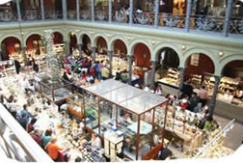
- Afternoon Lessons 15:00-17:00 h.:
ESCUELA TÉCNICA SUPERIOR DE INGENIEROS DE MINAS (UPM) Room: Aula de Informática (Comp. Lab.)

- Cultural Activities (see detailed programme)

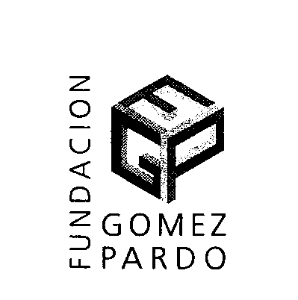
ACCOMODATION
- RESIDENCIA UNIVERSITARIA GOMEZ-PARDO
http://www.minas.upm.es/inicio/FGP/laresidencia.htm fgp.minas@upm.es

Street: Cristobal Bordiu, 30 Bis, 28003 Madrid
Phone Numbers:
  - + 34 91 441 79 21 – +34 91 442 26 56 (Administration)
  - + 34 91 442 29 20 (Reception Desk)
Fax Number: + 34 91 442 95 29
Facilities :
  - Situated next to “Rios Rosas” Metro Station, facing the Escuela Técnica Superior de Ingenieros de MINAS (UPM)
  - Individual bedroom with in-suite bathroom.
  - TV-Video Room.
  - Common Study Room.
  - Individual INTERNET connection in all the bedrooms.
  - Bedroom Weekday Cleaning (not weekends)
  - Laundrette (coin operated)
  - Spanish press available
  - 24 hours reception desk (Open entrance and leaving at any time)
  - Not kitchen facilities (just microwave)

PROGRAMME WORKFORCE
- Specialized Spanish language teachers from PROLINTER UPM
- Experts in different scientific and technical subject areas
- Specialized tourist guides
- Programme Secretaríat PROLINTER programa.lenguas @upm.es
- Academic Programme and Course Coordinator: Prof. Marinela García PROLINTER UPM

CONTACTS AT UPM
- Ms. Maria Luisa Escribano Programme Administrator
e-mail: marialuisa.escribano@upm.es
Phone Number: +34 91 336 6159
- Prof. Marinela García, Programme Director
e-mail: marinela.garcia@upm.es
Phone Number: +34 91 336 66 08
***********************************************

